Geology 101 Pima Community College Name_________________________

Date ______________

Chapter 14 Lab Activity 1: Coastal Geology and Geomorphology Exercise

Coastal Landforms and Phenomena of Sandy Coasts
Coastal processes are among the most dynamic geologic processes; change in the morphology of many coasts can be observed on annual (or shorter) time scales. The ever-pounding waves generated by winds at sea release tremendous quantities of energy along continental margins, constantly shaping coasts. In this exercise, you will identify a number of commonly observed coastal landforms and phenomena of sandy shores.
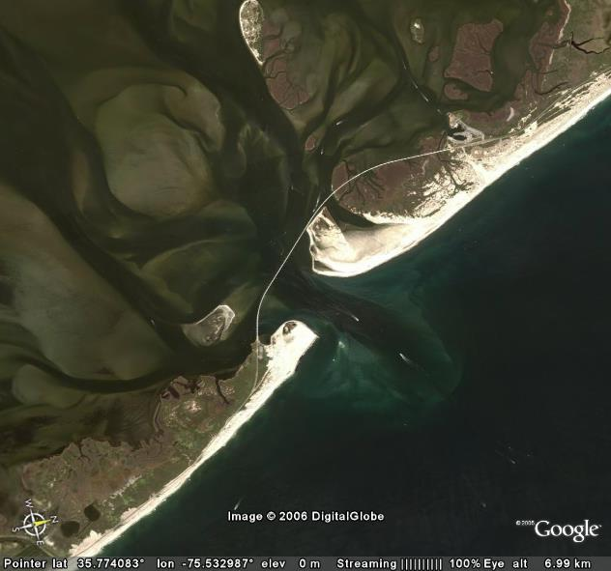
Fig. 1. Google Earth image of Oregon Inlet on the North Carolina Outer Banks.

In Google Earth, enter the coordinates below into the query bar:

35.773957 -75.532792 Oregon Inlet, North Carolina, USA
- Using the coordinates above, scan north and south of this point to locate the following coastal landforms and phenomena.
Barrier Island | Beach | Breaker | Beach Ridges
Cape | Coastal Plain | Cuspate Foreland | Dune
Ebb Tide Delta | Estuary | Flood Tide Delta | Inlet
Overwash Fan | Recurved Spit | Rip Current | Salt Marsh
Surf | Tidal Channel | Tidal Creeks | Wave Refraction
- Mark each landform or phenomenon you find with the ‘Placemark’ tool and label it.
- Save several images from Google Earth showing these landforms.
- When you have found all the landforms and saved images showing them, print each image to turn in to your instructor.
- Additional questions for this location:
  - What is the dominant wave direction in the images you examined?
  - What is the dominant longshore drift direction in the images you examined?
  - What evidence did you use to identify potential drift directions in these images?
  - What do you think are the sources of sand along these beaches?
  - Where is the beach the widest in these images?
  - Is there evidence of human-induced coastal change along this coast? Briefly describe the evidence for human impacts on this coast.

Links to Related Sites:
Coastal Geology in Our National Parks: http://www2.nature.nps.gov/geology/coastal/
Coasts in Crisis: http://pubs.usgs.gov/circ/c1075/
Overview of Coastal Land Loss: http://pubs.usgs.gov/of/2003/of03-337/sandy.html
Barrier Islands: http://www.nps.gov/guis/extended/MIS/MNature/Islands.htm
How Barrier Islands Work: http://science.howstuffworks.com/barrier-island.htm

